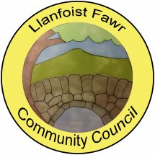
SUMMARY REGISTER OF DECLARATIONS OF INTEREST – 2024/25

MEETING  DATE | AGENDA  ITEM | COUNCILLOR | INTEREST DECLARED | TYPE OF INTEREST
17/04/24 | 9(ii) | Cllr G. Jones | Personal | Neighbour to planning application Consultees
15/05/24 | 9(ii) | Cllr G. Jones | Personal | Neighbour to planning application Consultees
19/06/24 | 8(iv) | Cllr R. Francis | Personal | Member of Abergavenny Allotment Association
17/07/24 | 5 | Cllr G. Jones | Personal | Independent Member of MCC Schools Admission Appeals Committee
18/09/24 | 11(5) | Cllr J. Faragher | Personal | Resident of Dan Y Bryn
16/10/24 |  |  | None declared
20/11/24 |  |  | None declared
15/01/25 | 9(ii) | Cllr R. Francis | Personal | Associate of Applicant
19/02/25 | 8(iii) | Cllr B. Russell | Personal | Officer of St Helens Church, Llanellen
05/03/25 | 4 | Cllr R.Byrne | Personal | Immediate Family Member of Trustee
19/03/25 |  |  | None declared

