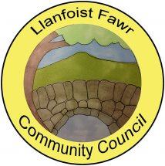

ANNUAL REPORT
Year Ended 31st March 2025

Adopted by Full Council 19th November 2025
INTRODUCTION
Llanfoist Fawr Community Council (LFCC) is a non-political, elected tier of local government which is closest to the people. The Council consists of 13 volunteer Ward Councillors and represents the interests of the communities of Govilon, Llanfoist and Llanellen. Sections of this community sit within the boundary of the Bannau Brycheiniog National Park. The remainder are semi-rural communities within the boundary of Monmouthshire County Council. The Community Council can influence other decision makers such as the Local Planning Authorities (Bannau Brycheiniog National Park) and the Unitary Authority, (Monmouthshire County Council) through its role as a statutory planning consultee. It also has powers to provide amenities such as the Salisbury Community Hall, Govilon and Llanellen Village Hall. Recreation grounds such as Centenary Field, Llanfoist (including Llanfoist Multi Use Games Area), Old School Meadow - Llanfoist, Owain Glyndwr Playing Field - Llanellen and the King George V Playing Field - Govilon (including the Govilon Sports Pavilion) are also provided. The community has a total population in excess of 3,500 and covers an area of circa 20 square miles. The Monmouthshire to Brecon Canal also runs through Llanellen, Llanfoist and Govilon respectively possessing its own unique and biodiverse systems.

LFCC’s objective is to protect and enhance the locality and help build a strong community

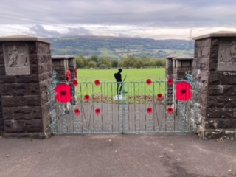

King George V Memorial Gardens, Govilon - Refurbished Gates

FINANCE

LFCC receives the majority of it’s funding from the Precept. The Council recognised the cost of living difficulties faced by residents to keep the 2024/25 Precept at £60,000 for the second year in succession. This consolidates upon a 12% reduction from £68,000 for the 2023/24 financial year. This funding is supplemented by a modest income received from the hire of the various community amenities which was £7,440 for the year to March 2025. LFCC works hard to keep hire fees to a minimum to offer these facilities at affordable costs to the community at large.
The most significant items of expenditure during the year ended March 2025 can be seen below. They are represented as a % of the Precept.

Recreation Grounds Maintenance | 26%
Salaries & Councillor Allowances | 25%
Facility Running Costs | 16%
Christmas Light Features | 11%
Dog Waste Contract | 10%
Insurances | 7%

AUDIT

The Council’s accounts for the year ended March 2025 have been internally audited by Catherine A Williams Ltd of Crickhowell. They are also subject to external audit by Audit Wales and the outcome will be published on the Council’s website in due course at:
https://www.llanfoist-fawr-community-council.co.uk/council/audit-finance/

TRAINING

The Council is a member of One Voice Wales and, in accordance with measures contained in the Local Government & Elections (Wales) Act 2021, a formal training policy has been published which can also be viewed on the Council’s website at:
https://www.llanfoist-fawr-community-council.co.uk/policies-reports/

Councillors are expected to hold core competences in the Code of Conduct and Financial Governance.

ACTIVITIES & ACHIEVEMENTS 2024-2025

LFCC made donations amounting to £1,950 to local good causes during the year to March 2025. Support was provided to Abergavenny Allotment Association, Brynmawr Rotary Stepping Forward Project, Monmouthshire Citizens Advice and MIND Monmouthshire. The Council also contributes towards the maintenance of the village cemeteries in Govilon, Llanfoist and Llanellen.

The memorial gates and railings at King George V Memorial Garden, Govilon were refurbished during the year at a cost of £1,670. Specialist metalwork contractors transported the gates and railings off-site to be sand-blasted, powder coat painted and reinstalled.

A successful grant application was made to the Bannau Brycheiniog Sustainable Development Fund for an energy efficiency investment to Govilon Sports Pavilion. This grant enabled the installation of Thermafleece sheep wool loft insulation along with a significant upgrade to the Pavilion lighting system to include movement sensor controlled LEDs.

In response to resident feedback, the benches within Owain Glyndwr Field, Llanellen were renewed and set onto a paving slab base to improve accessibility. The new benches are constructed from recycled plastic and will require minimal maintenance going forward.

Four permanently accessible defibrillators are installed: Two in Govilon, one in Llanfoist and one at Llanellen Village Hall. Continual status monitoring, pad replacement and maintenance of these life-saving assets continues to be funded by LFCC.

Annual funding was continued to maintain the festive lighting features which complete a display from Llanfoist Bridge through to the western edges of Govilon – a grand total of 46 features. Unfortunately, existing street column infrastructure does not permit lights in Llanellen but the Community Council continues to support the Llanellen community in other ways as demonstrated elsewhere in this Report.

Four recreation areas are also maintained by LFCC for the community’s enjoyment. There are two in Llanfoist - Centenary Field and Old School Meadow along with the Owain Glyndwr Field in Llanellen and King George V Field in Govilon.

Land Adjacent to Govilon Recreation Ground

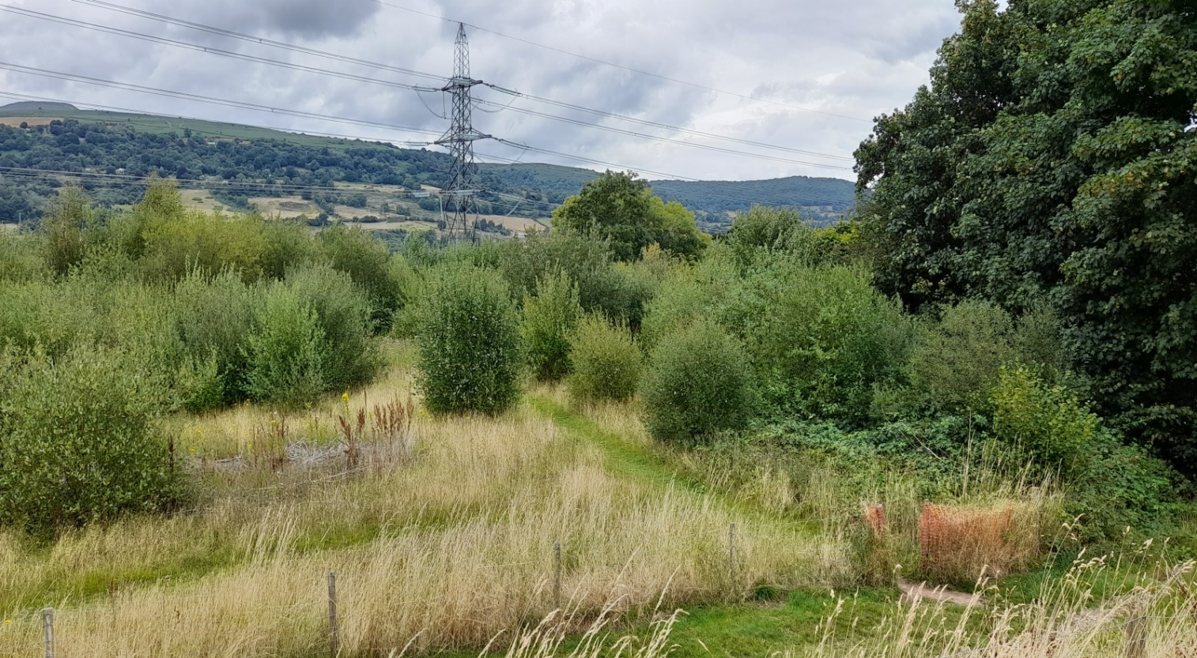

Govilon residents will be familiar with the parcel of land adjacent to the football pitch at the King George V Recreation Ground (above). Whilst this land is not owned by LFCC, the only access is through Council property and the Council has been liaising closely with the Charity Commission with a view to developing this land recreationally for the inclusive benefit of the community. Extensive consultation with Govilon residents was carried out and a range of preferred uses were identified.

“Top of the Pops” were, in no particular order!
- Nature & Wildlife Trail
- Community Growing / Allotment Area
- Activity & Adventure Play Area(s)
- Dog Walk Extension
- Outdoor Gym Zone
- Benches & Picnic areas

During 2024/25, LFCC invested over £3,000 on an ecology study and landscape design plans to capture elements of this positive community feedback and it is hoped these can be progressed into firmer plans and designs to be delivered in 2025/26.

KEY OBJECTIVES FOR 2025 onwards

The Community Council continually listens to its electorate. Your Community Council regularly consults with members of the community for your views whether by holding drop in sessions or more formal consultation regarding potential uses for Section 106 funding. Please keep an eye on the Council’s social media page and/or the website at:
https://www.llanfoist-fawr-community-council.co.uk/

A number of objectives were identified during the budget setting process for the 2024/25 financial year. These included:
- To resurface the overspill car park area at Centenary Field, Llanfoist.
- Continuation of a process of community and Charity Commission liaison to develop the parcel of land adjacent to King George V Playing Fields, Govilon.
- Additional public engagement events in council wards
- A commitment to become a Dementia Friendly Council
- A review of the Council’s Grants Policy to foster a wider cohort of applications
- To commit to comprehensive public consultation on the use of Section 6 funding arising from the Rossers Field development in Govilon.
- Redecoration of the changing rooms at Govilon Sports Pavilion
- Enhance play equipment provision at Owain Glyndwr Field, Llanellen
- To explore opportunities to build upon the provision of public access defibrillators

Many thanks for taking the time to read this Annual Report. It is hoped you found it informative. Please remember that your Community Councillors can all be contacted individually – contact numbers are provided on the website at:
https://www.llanfoist-fawr-community-council.co.uk/councillors/

Alternatively, if you prefer to email the Community Council the contact address is: clerk@llanfoistfawrcc.co.uk

