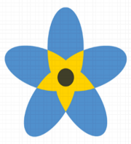
Become a Dementia Friend!

Find out about the 5 key messages we think everyone should know about Dementia and what life is like for people living with the disease.
Dementia Friends is about learning more about the small ways you can help people in the community.

Join us for a 45 minute awareness session!

Tuesday 12th March 2024
1pm – 3pm
Salisbury Community Hall
Govilon
NP7 9PT

This session is suitable for all members of the community, volunteers, professionals and for family members.

