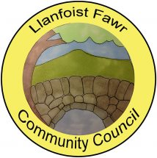

ANNUAL REPORT
Year Ended 31st March 2023

Adopted by Full Council 20th September 2023
INTRODUCTION
Llanfoist Fawr Community Council (LFCC) is a non-political, elected tier of local government which is closest to the people. The Council consists of 13 voluntary Ward Councillors and represents the interests of the communities of Govilon, Llanfoist and Llanellen. Sections of this community sit within the boundary of the Bannau Brycheiniog National Park. The remainder are semi-rural communities within the boundary of Monmouthshire County Council. The Community Council can influence other decision makers such as the Local Planning Authorities (Bannau Brycheiniog National Park) and the Unitary Authority, (Monmouthshire County Council) through its role as a statutory planning consultee. It also has powers to provide amenities such as the Salisbury Community Hall, Govilon and Llanellen Village Hall. Recreation grounds such as Centenary Field, Llanfoist (including Llanfoist Multi Use Games Area), Old School Meadow - Llanfoist, Owain Glyndwr Playing Field - Llanellen and the King George V Playing Field - Govilon (including the Govilon Sports Pavilion) are also provided. The community has a total population in excess of 3,500 and covers an area of circa 20 square miles. The Monmouthshire to Brecon Canal also runs through Llanellen, Llanfoist and Govilon respectively possessing its own unique and biodiverse systems.

LFCC’s objective is to protect and enhance the locality and help build a strong community

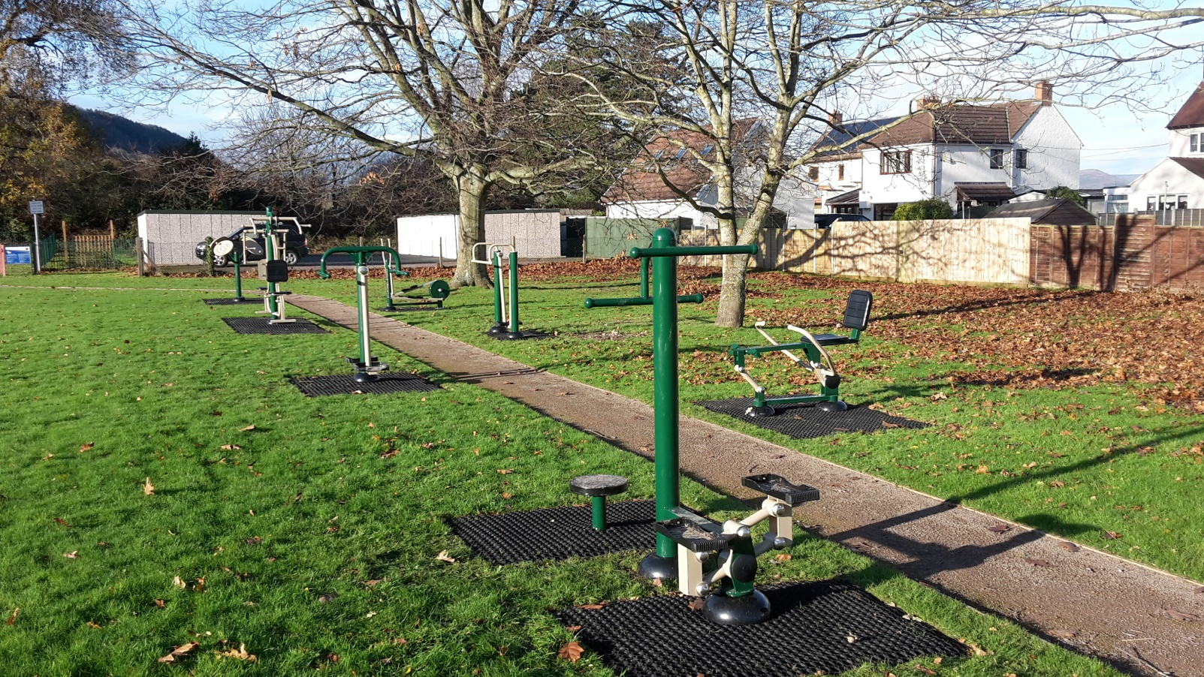

Outdoor gym equipment at Owain Glyndwr Playing Field, Llanellen

FINANCE

LFCC receives the majority of it’s funding from the Precept which was maintained at the previous year level of £68,000.
This funding is supplemented by a modest income received for the hire of the various community amenities which was £5,429 for the year to March 2023. LFCC works hard to keep hire fees to a minimum to offer these facilities at affordable costs to the community at large.
The most significant items of expenditure during the year ended March 2023 can be seen below. They are represented as a % of the Precept.

Recreation Grounds Maintenance | 17%
Salaries & Allowances | 23%
Facility Running Costs | 10%
Dog Waste Contract | 8%
Insurances | 7%
Christmas Light Features | 7%

AUDIT

The Council’s accounts for the year ended March 2023 have been internally audited by Catherine A Williams Ltd of Crickhowell. They are also subject to external audit by Audit Wales and the outcome will be published on the Council’s website in due course at:
https://www.llanfoist-fawr-community-council.co.uk/council/audit-finance/

TRAINING

The Council is a member of One Voice Wales and, in accordance with measures contained in the Local Government & Elections (Wales) Act 2021, a formal training policy has been published which can also be viewed on the Council’s website at:
https://www.llanfoist-fawr-community-council.co.uk/policies-reports/

Councillors are expected to hold core competences in the Code of Conduct and Financial Governance.

ACTIVITIES & ACHIEVEMENTS 2023

LFCC made donations amounting to £3,968 to local good causes during the year to March 2023. Support was provided to Monmouthshire Citizens Advice, Wales Air Ambulance, URDD National Eisteddfod, Gwent Young Farmers and the Summer Play Scheme operated in Abergavenny by Monmouthshire CC which is known to support families and children living in the Llanfoist Fawr catchment during the school holidays.

Following requests from the Llanellen community, LFCC were pleased to fund the supply and installation of an outdoor table tennis table. This has proved a very popular addition to the existing outdoor gym equipment and provides exercise opportunities for all ages.

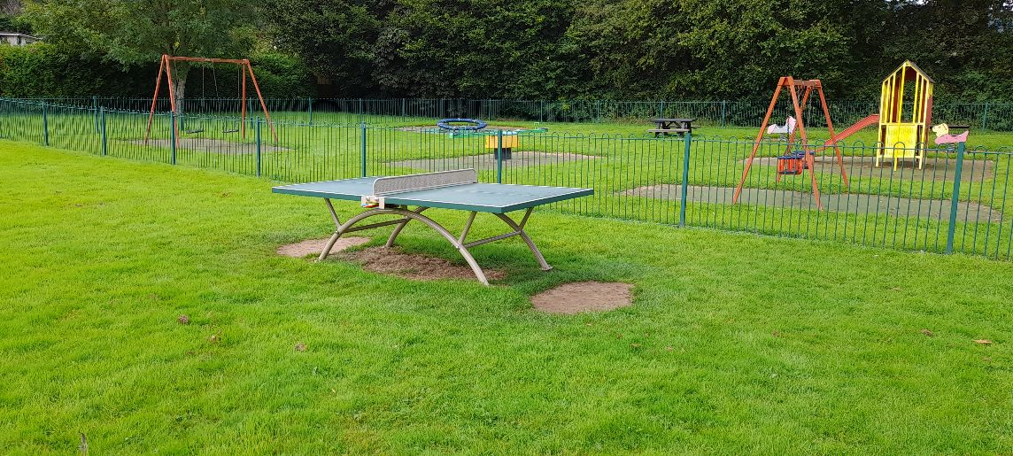

Four permanently accessible defibrillators are now installed: Two in Govilon at Salisbury Community Hall and the Govilon Sports Pavilion, plus one at St Faiths Church Hall in Llanfoist and one at Llanellen Village Hall. Continual status monitoring and maintenance of these life-saving assets is supported and funded by LFCC.

Christmas lighting features were also funded to provide a festive display which completes a trail from Llanfoist Bridge through to the western edges of Govilon – a grand total of 42 features. Unfortunately, street column infrastructure does not permit lights in Llanellen but the Community Council continues to support the Llanellen community as demonstrated with the above outdoor tennis table.

Four recreation areas are also maintained by LFCC for the community’s enjoyment. There are two in Llanfoist - Centenary Field and Old School Meadow along with the Owain Glyndwr Field in Llanellen and King George V Field in Govilon.
LFCC continued to partner with HM Prison and Probation Service during the year. Invaluable support from this Team has helped maintain the four large raised fruit tree beds at Govilon Recreation Ground and has kept a “forest” of brambles at bay along the perimeter of Centenary Field, Llanfoist.

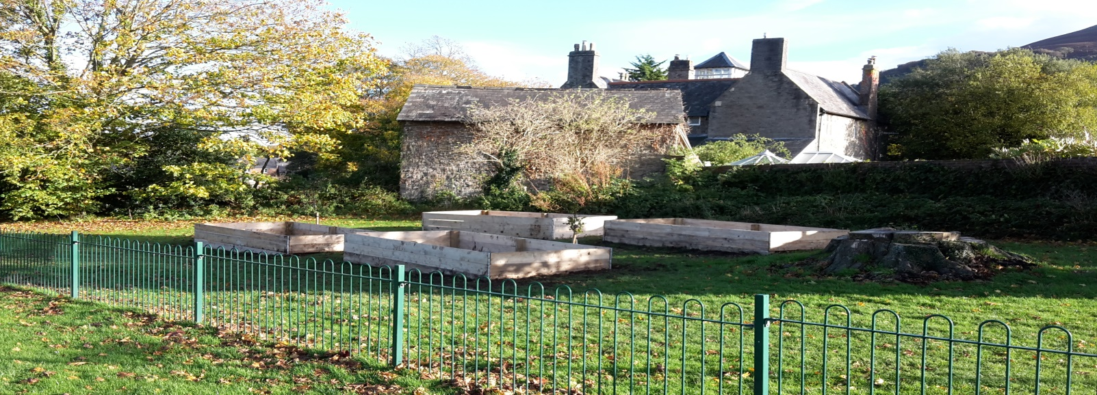

KEY OBJECTIVES FOR 2024

Following local elections in May 2022, a brand new Community Council has been elected and has launched a community engagement process in preparation for the publication of a three year community plan. This Plan will look to settle upon options for projects within the communities of Llanfoist, Llanellen and Govilon for delivery during this five year council term . Your Community Council will be consulting with all members of the community for your views on what you would like to see so please keep an eye on the Facebook page and/or the website at:
https://www.llanfoist-fawr-community-council.co.uk/

Many thanks for taking the time to read this Annual Report. It is hoped you found it informative. Please remember that your Community Councillors can all be contacted individually – contact numbers are provided on the website at:
https://www.llanfoist-fawr-community-council.co.uk/councillors/

Alternatively, if you prefer to email the Community Council the contact address is: clerk@llanfoistfawrcc.co.uk

