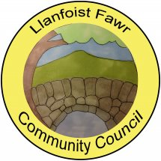
SUMMARY REGISTER OF DECLARATIONS OF INTEREST – 2022/23

MEETING  DATE | AGENDA  ITEM | COUNCILLOR | INTEREST DECLARED | TYPE OF INTEREST
07/04/22 |  |  | None declared
20/04/22 | 8(vi) | Cllr B. Russell | Personal | Officer of Llanellen Village Hall Committee
07/06/22 |  |  | None declared
22/06/22 |  |  | None declared
20/07/22 |  |  | None declared
21/09/22 | 9(ii) | Cllr J. Faragher | Personal | Friend of planning applicant
19/10/22 |  |  | None declared
16/11/22 |  |  | None declared
12/01/23 | 4 | Cllr M. Pearson | Personal | Business relationship with contractor tendering
18/01/23 | 6(ii) | Cllr B. Russell | Personal | Officer of St Helens Church, Llanellen
15/02/23 | 9(v)  9(ii) | County Cllr B. Callard  Cllr H. Thomas | Personal  Personal | Member of Mon CC Planning Committee  Neighbour Consultee
15/03/23 | 8(ii) | Cllr M. Pearson | Personal | Friend of planning applicant

