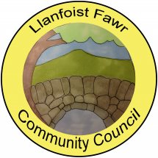
SUMMARY REGISTER OF DECLARATIONS OF INTEREST – 2021/22

MEETING  DATE | AGENDA  ITEM | COUNCILLOR | INTEREST DECLARED | TYPE OF INTEREST
21/04/21 |  |  | None declared
26/05/21 |  |  | None declared
16/06/21 |  |  | None declared
21/07/21 |  |  | None declared
15/09/21 |  |  | None declared
21/10/21 | 11 | Clerk (G.Havard) | Personal | Written complaint to LFCC regarding Clerk
17/11/21 |  |  | None declared
19/01/22 | 6(ii) | Cllr B. Russell | Personal | Officer of Llanellen Village Hall Committee
16/02/22 |  |  | None declared
16/03/22 |  |  | None declared
30/03/22 |  |  | None declared

