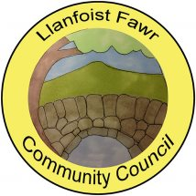 | Clerk: Gareth Havard  19, Derwen Deg Close  Govilon  Monmouthshire  NP7 9RJ  Tel: 07850 543434  clerk@llanfoistfawrcc.co.uk  www-llanfoist-fawr-community-council.co.uk

COMMUNITY ENGAGEMENT
Llanfoist Fawr Community Council will be hosting a “drop in” engagement session for Llanellen residents on:

Thursday, September 21st 2023

between 5pm and 7.30pm at the Llanellen Village Hall

Please feel free to call in if you would like to:
- Meet your Ward Councillors
- Understand more about how your Community Council works for you
- Share your ideas about future improvements to your community

