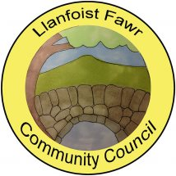 | Clerk: Gareth Havard  19, Derwen Deg Close  Govilon  Monmouthshire  NP7 9RJ  Tel: 07850 543434  clerk@llanfoistfawrcc.co.uk  www-llanfoist-fawr-community-council.co.uk

COUNCILLOR VACANCIES
- Do you care passionately about your local community?
- Is there something you want to change or improve for residents?
- Are you ready to take challenging decisions?
- Why not stand for what you care about and become a Community Councillor?

There are currently 3 vacancies for Co-Opted Members to Llanfoist Fawr Community Council - two in the Llanfoist Ward and one in the Govilon Ward.

Candidates are eligible for co-option to a community council if any of the following apply:
- the candidate is on the electoral register for the community in question, or
- has either during the whole of the twelve months before the day on which he is applying as a candidate, resided in the locality or within three miles of it, or
- occupied as owner or tenant any land or premises therein, or
- had his principal or only place of work there
For clarity, only one of the above categories needs to be satisfied for eligibility.

Interested and eligible candidates are invited to contact the Clerk for further information.

