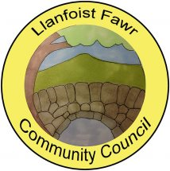

ANNUAL REPORT
Year Ended 31st March 2022

Adopted by Full Council 19th October 2022
INTRODUCTION
Llanfoist Fawr Community Council (LFCC) is a non-political, elected tier of local government which is closest to the people. The Council consists of 13 voluntary Ward Councillors and represents the interests of the communities of Govilon, Llanfoist and Llanellen. Sections of this community sit within the boundary of the Brecon Beacons National Park. The remainder are semi-rural communities within the boundary of Monmouthshire County Council. The Community Council can influence other decision makers such as the Planning Authority (Brecon Beacons National Park) and the Unitary Authority, (Monmouthshire County Council) through its role as a statutory planning consultee. It also has powers to provide amenities such as the Salisbury Community Hall, Govilon and Llanellen Village Hall. Recreation grounds such as Centenary Field, Llanfoist (including Llanfoist Multi Use Games Area), Old School Meadow - Llanfoist, Owain Glyndwr Playing Field - Llanellen and the King George V Playing Field - Govilon (including the Govilon Sports Pavilion) are also provided. The community has a total population in excess of 3,500 and covers an area of circa 20 square miles. The Monmouthshire to Brecon Canal also runs through Llanellen, Llanfoist and Govilon respectively possessing its own unique and biodiverse systems.

LFCC’s objective is to protect and enhance the locality and help build a strong community

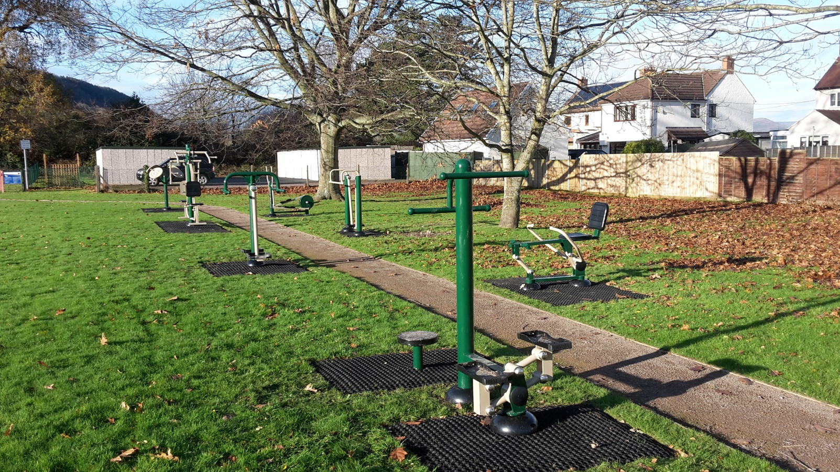

Outdoor gym equipment at Owain Glyndwr Playing Field, Llanellen

FINANCE

LFCC receives the majority of it’s funding from the Precept which was kept the same as the previous year at £68,000
This funding is supplemented by a modest income received for the hire of the various community amenities which was £6,326 for the year to March 2022. LFCC works hard to keep hire fees to a minimum to offer these facilities at affordable costs to the community at large.
The most significant items of expenditure during the year ended March 2022 can be seen below. They are represented as a % of the Precept.

Recreation Grounds Maintenance | 26%
Salaries & Allowances | 22%
Facility Running Costs | 9%
Dog Waste Contract | 7%
Insurances | 6%
Christmas Light Features | 6%

AUDIT

The Council’s accounts for the year ended March 2022 have been internally audited by Catherine A Williams Ltd of Crickhowell. They are also subject to external audit by Audit Wales and the outcome will be published on the Council’s website in due course at:
https://www.llanfoist-fawr-community-council.co.uk/council/audit-finance/

TRAINING

The Council is a member of One Voice Wales and, in accordance with measures contained in the Local Government & Elections (Wales) Act 2021, a formal training plan will be published later in the year. Councillors are expected to hold core competences in the Code of Conduct and Financial Governance.

ACTIVITIES & ACHIEVEMENTS 2022

LFCC made donations amounting to £2,350 to local good causes during the year to March 2022. Support was provided to MIND Monmouthshire, Monmouthshire Citizens Advice and the Summer Play Scheme operated in Abergavenny by Monmouthshire CC which is known to support families and children living in the Llanfoist Fawr catchment during the school holidays.

Another life-saving defibrillator was also installed at the Govilon Sports Pavilion. The bulk of the funding was provided by the Community Council but valuable funds were also contributed by Forgeside and Abergavenny Rhinos football clubs. There are now four defibrillators managed by LFCC in the community.

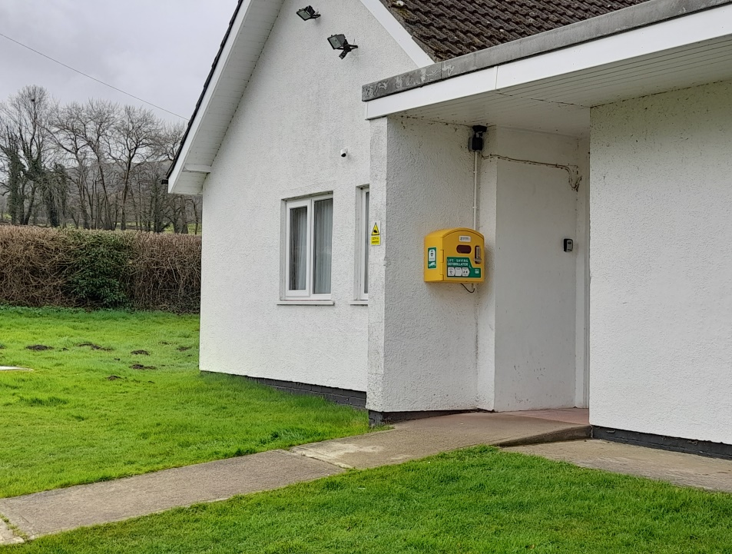

Christmas lighting features were also extended in December 2021 to provide a festive display which completes a trail from Llanfoist Bridge through to the western edges of Govilon – a grand total of 42 features. Unfortunately, street column infrastructure does not permit lights in Llanellen but the Community Council funded replacement of the hardwood Christmas decoration displayed annually outside Llanellen Village Hall as some recompense.

LFCC also partnered with the Brecon Beacons National Park Authority and HM Prison and Probation Service during 2021 to install four large raised fruit tree beds at Govilon Recreation Ground.
As part of a nature recovery initiative, the timber raised beds were constructed by the community and filled with 32 tonnes of top soil by participants in the community payback scheme.

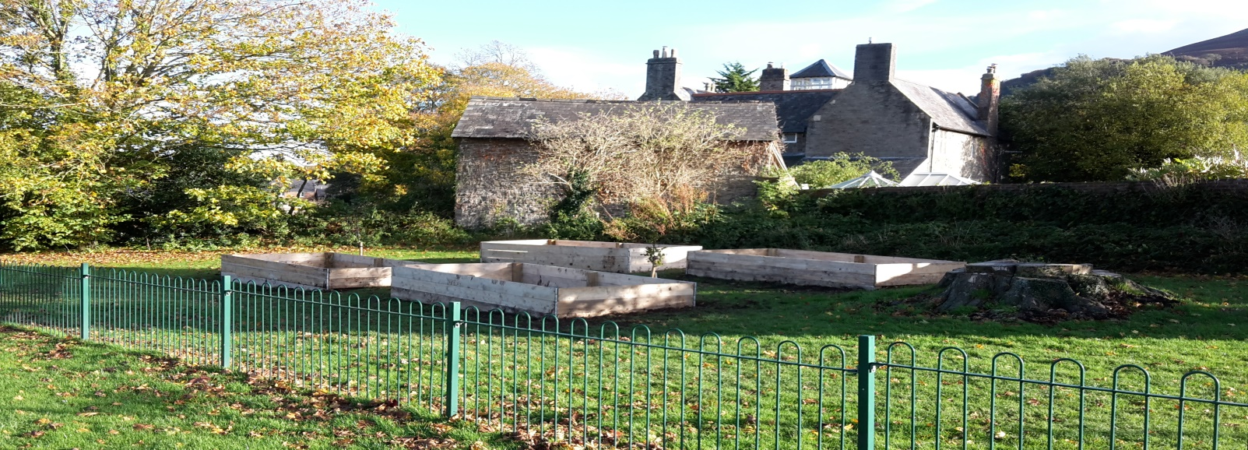

A variety of fruit bushes have been planted and a harvest is hoped for next year.

KEY OBJECTIVES FOR 2023

Following local elections in May 2022, a brand new Community Council has been elected and is already planning new initiatives for Llanfoist Fawr. Community engagement is key and a first step is the introduction of a Community Council Facebook page.
Work is also underway on the preparation of a three year community plan which will look to settle upon options for projects within the communities of Llanfoist, Llanellen and Govilon for delivery during this five year council term . Your Community Council will be consulting with all members of the community for your views on what you would like to see so please keep an eye on the Facebook page and/or the website at:
https://www.llanfoist-fawr-community-council.co.uk/

Many thanks for taking the time to read this Annual Report. It is hoped you found it informative. Please remember that your Community Councillors can all be contacted individually – contact numbers are provided on the website at:
https://www.llanfoist-fawr-community-council.co.uk/councillors/

Alternatively, if you prefer to email the Community Council the contact address is: clerk@llanfoistfawrcc.co.uk

