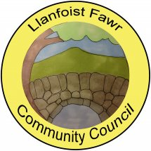
SUMMARY REGISTER OF DECLARATIONS OF INTEREST – 2020/21

MEETING  DATE | ITEM | COUNCILLOR | INTEREST DECLARED | TYPE OF INTEREST
27/05/20 |  |  | None declared
17/06/20 |  |  | None declared
15/07/20 | 4 | Cllr B. Russell | Trustee of Llanellen Village Hall Management Committee | Personal & Prejudicial
 | Planning | Cllr M. Butler | Neighbour of applicant. DM/2020/00807 | Personal
16/09/20 |  |  | None declared
21/10/20 |  |  | None declared
18/11/20 |  |  | None declared
20/01/21 |  |  | None declared
17/02/21 | 10(ii) | Cllr M. Davies | Neighbour to Applicant DM/2020/01885 | Personal
17/03/21 |  |  | None declared

