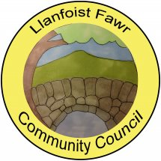SUMMARY REGISTER OF DECLARATIONS OF INTEREST – 2018/19

MEETING  DATE | ITEM | COUNCILLOR | INTEREST DECLARED | TYPE OF INTEREST
18/04/18 |  |  | None declared
16/05/18 |  |  | None declared
20/06/18 | 6(7) | Cllr J Smith | Chair of Llanfoist Village Hall Management Committee | Prejudicial
18/07/18 |  |  | None declared
21/08/18 | 3 | Cllr C Holland | Applicant’s architect is personal acquaintance. | Personal
19/09/18 |  |  | None declared
17/10/18 | 5(6) | Cllr B McDonald | Officer of Abergavenny Garden Centre Ltd. | Personal & Business
06/11/18 |  |  | None declared
28/11/18 |  |  | None declared
05/12/18 |  |  | None declared
09/01/19 |  |  | None declared
15/01/19 | 9 | Cllr A Sussex | Member of organisations filing grant applications | Personal
05/02/19 | 4 | Cllr A Sussex | Neighbour of applicant  19/17015/FUL | Personal
20/02/19 |  |  | None declared
20/03/19 |  |  | None declared

